***NAME : Himanshu Dixit***

***ENROLL NO. : B64178***

***BATCH : B10***

***SOFTWARE DEVELOPMENT FUNDAMENTAL LAB-I(15B17CI171) Assignment Sheet (WEEK-4 PHASE-2)***

***Lab B***

***Write a C Program to do the following:***

***1.****Print 10 random numbers in the range of 0-50 and print them as the following pattern.*

*Example:*

*Enter the number of rows: 5*

*10*

*49 9*

*34 32 37*

*37 48 45 19*

*5 31 20 19 29*

***Solution:***

*#include<stdio.h>*

*#include<stdlib.h>*

*#include<time.h>*

*int main()*

*{*

*int n;*

*srand(time(NULL));*

*printf("enter number of rows : ");*

*scanf("%d",&n);*

*for(int i=0;i<n;i++)*

*{*

*for(int j=0;j<=i;j++)*

*{*

*printf("%d ", rand()%51);*

*}*

*printf("\n");*

*}*

*return 0; }*

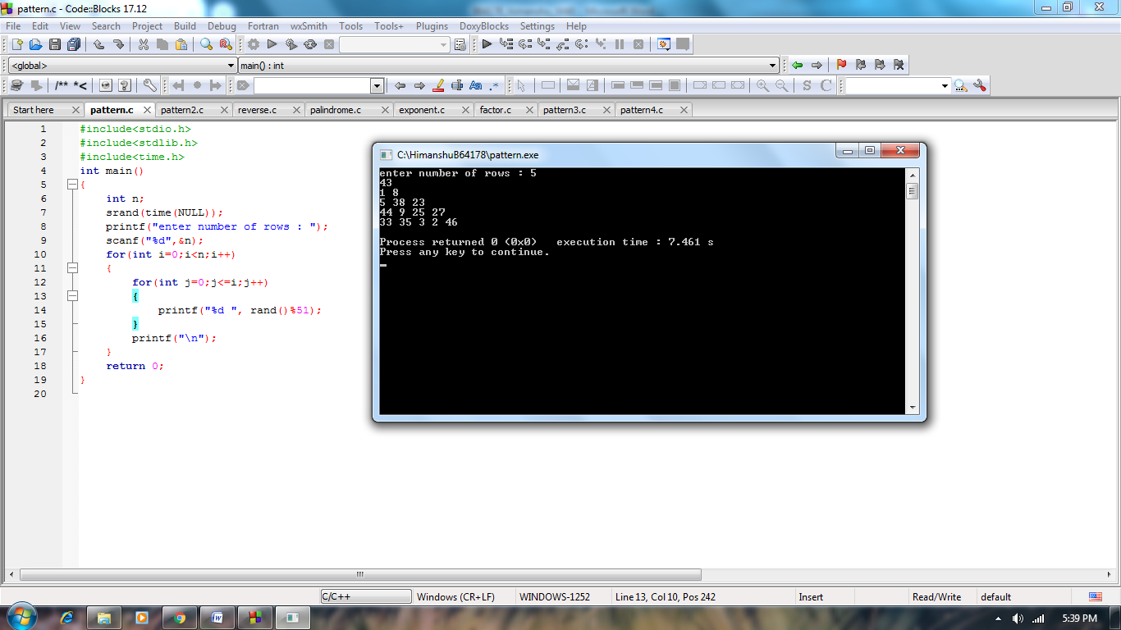

***2.****Generate the following pattern as shown below:*

*Enter the number of rows: 4*

*11*

*22      33      22*

*33      44      55      44      33*

*44      55      66      77      66      55      44*

***Solution:***

*#include<stdio.h>*

*int main()*

*{*

*int n,a=1,k=2,i,j;*

*printf("enter number of rows : ");*

*scanf("%d",&n);*

*for(i=0;i<n;i++)*

*{*

*int c=1;*

*for(j=0;j<n;j++)*

*{*

*if(i+j>=n-1)*

*{*

*printf("%d", a*11);*

*a++;*

*}*

*else*

*{*

*printf(" ");*

*}*

*}*

*if(j==n&&i!=0)*

*{a--;*

*while(c<=i)*

*{*

*a=a-1;*

*printf("%d",a*11);*

*c++;*

*}*

*}*

*a=k;*

*k=k+1;*

*printf("\n");*

*}*

*return 0;*

*}*

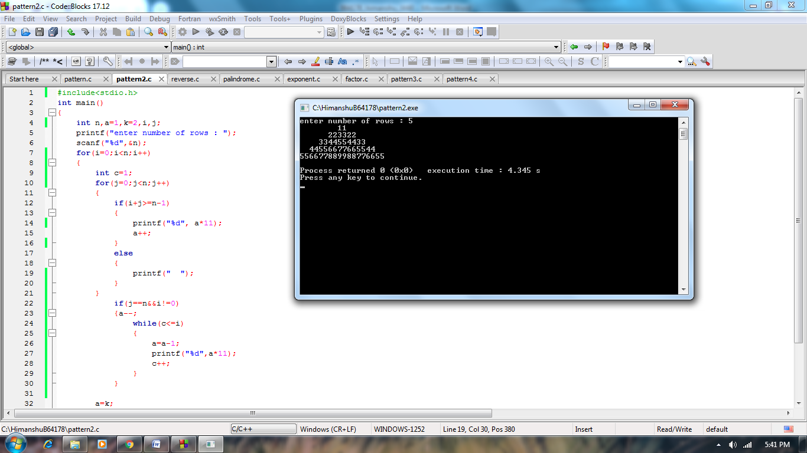

***3.****Reverse the digits of a given number.*

***Solution:***

*#include<stdio.h>*

*int main()*

*{*

*int num,a,rev=0;*

*printf("Enter the number : ");*

*scanf("%d",&num);*

*while(num>0)*

*{*

*a=num%10;*

*num=num/10;*

*rev=rev*10+a;*

*}*

*printf("Reverse of the number is : %d",rev);*

*return 0;*

*}*

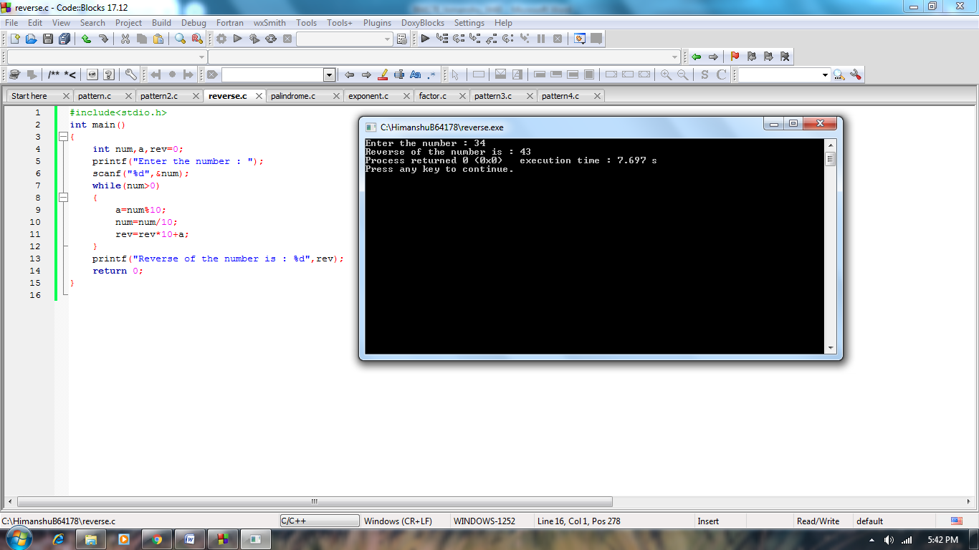

***4.****Check whether a number is a palindrome or not.*

***Solution:***

*#include<stdio.h>*

*int main()*

*{*

*int num,a,b,rev=0;*

*printf("Enter the number : ");*

*scanf("%d",&num);*

*b=num;*

*while(num>0)*

*{*

*a=num%10;*

*num=num/10;*

*rev=rev*10+a;*

*}*

*if(b==rev)*

*{*

*printf("%d is a palindrome number",rev);*

*}*

*else*

*{*

*printf("%d is not a palindrome number",b);*

*}*

*return 0;*

*}*

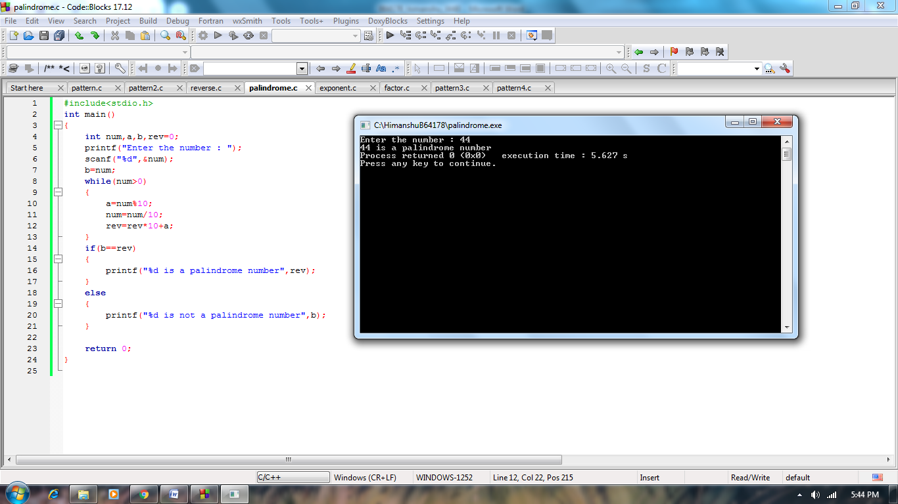

***5.****Generate the value of the* ***n*** *to the power* ***a****, without using direct function.*

***Solution:***

*#include<stdio.h>*

*int main()*

*{*

*int num,b,exp=1,pow;*

*printf("Enter the number : ");*

*scanf("%d",&num);*

*printf("Enter the power : ");*

*scanf("%d",&pow);*

*b=pow;*

*while(pow>0)*

*{*

*exp=exp*num;*

*pow--;*

*}*

*printf("%d ^ %d = %d",num,b,exp);*

*return 0;*

*}*

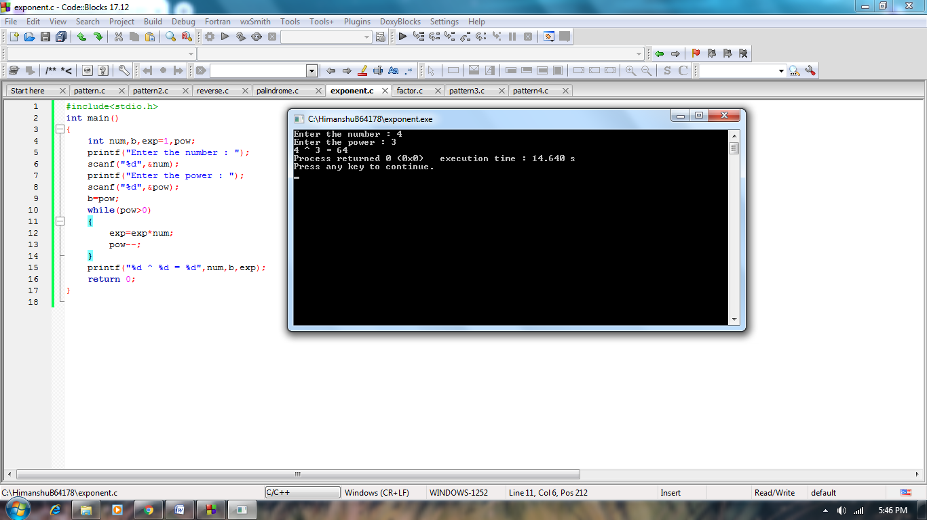

***6.****Generate all the factors of a given +ve integer.*

***Solution:***

*#include<stdio.h>*

*int main()*

*{*

*int num,fact=1,i=1;*

*printf("Enter the number : ");*

*scanf("%d",&num);*

*printf("factors are : ");*

*while(i<=num)*

*{*

*if(num%i==0)*

*printf("%d ",i);*

*i++;*

*}*

*return 0;*

*}*

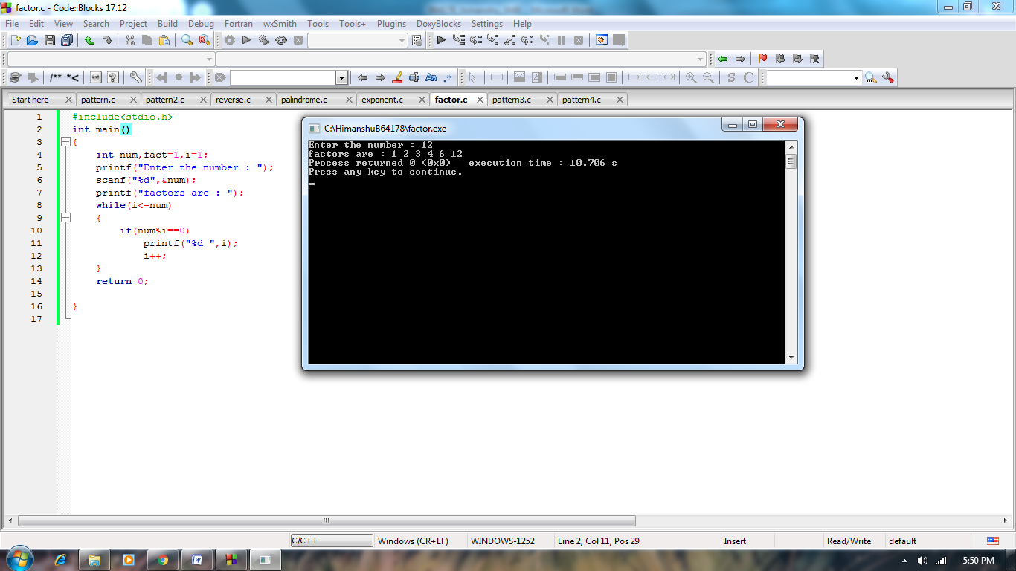

***7.****Generate the following pattern:*

*Enter the number of rows7*

*#######*

*# # # #*

*# #  # #*

*# #   #*

*#  #  #  #*

*# #    # #*

*#######*

***Solution:***

*#include<stdio.h>*

*int main()*

*{*

*int i,j,r;*

*printf("enter the rows : ");*

*scanf("%d",&r);*

*for(i=0;i<r;i++)*

*{*

*for(j=0;j<r;j++)*

*{*

*if(i==0||i==r-1||j==0||j==r-1||i==j||i+j==r-1)*

*printf("#");*

*else*

*printf(" ");*

*}*

*printf("\n");*

*}*

*return 0;*

*}*

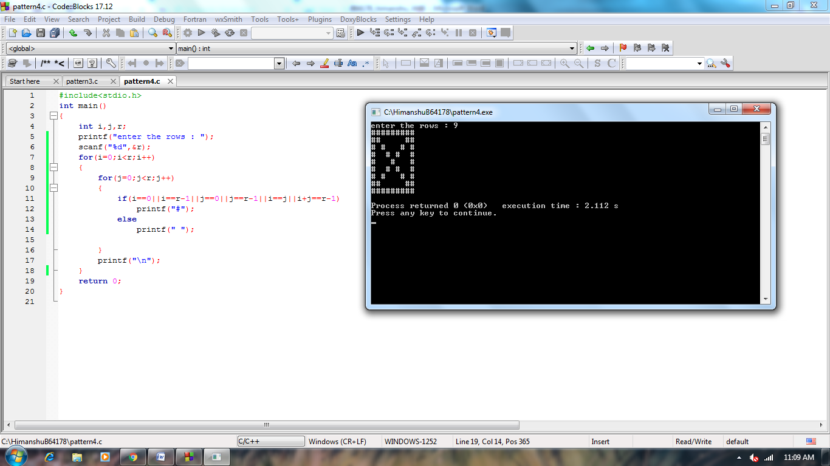

***8.****Generate the following pattern:*

*Enter the number of rows6*

*\*\*\*\*\*\**

*\*        \**

*\*         \**

*\*         \**

*\*         \**

*\*\*\*\*\*\**

***Solution:***

*#include<stdio.h>*

*int main()*

*{*

*int i,j,r;*

*printf("enter the rows : ");*

*scanf("%d",&r);*

*for(i=0;i<r;i++)*

*{*

*for(int space=0;space<i;space++)*

*printf(" ");*

*for(j=0;j<r;j++)*

*{*

*if(i==0||j==0||j==r-1||i==r-1)*

*printf("*");*

*else*

*printf(" ");*

*}*

*printf("\n");*

*}*

*return 0;*

*}*

